**Kol simcha torah gazette**

**For parshas tazria 5784**

Volume 8 Issue 31 (Whole #389) 5 Nisan 5784/ April 13, 2023

**Printed L’illuy nishmas Nechama bas R’ Noach, a”h**

For a free subscription, please forward your request to [***keren18@juno.com***](mailto:keren18@juno.com)

***Past emails can be found on the website ShabbosStories.com under Brooklyn Torah Gazette***

**Nigerian Bar Mitzvah Boy’s Gift of Water to Muslim Village**

**By**[**Nancy K. S. Hochman**](https://www.chabad.org/search/keyword_cdo/kid/20474/jewish/Hochman-Nancy-KS.htm)



**Yossi Uzan, 13, chose to honor his becoming a bar mitzvah by helping finance a source of clean potable water for residents of the village of Atunda.** *Photo: Chabad of Abuja*

Until now, the villagers of Atunda Village in Nigeria had to walk miles to access safe drinking water.

But last month, Yossi Uzan, 13, chose to honor his becoming a bar mitzvah by helping finance a source of clean potable water for its residents. He was influenced by the charitable giving of his parents, Rabbi Israel and Haya Uzan, co-directors of Chabad Lubavitch of Nigeria in the capital city of Abuja.



**In attendance at the bar**[**mitzvah**](https://www.chabad.org/library/article_cdo/aid/1438516/jewish/Mitzvah.htm)**were congregants and more than 2,000 Nigerian neighbors and friends.** *Photo: Chabad of Abuja*

Today, the recently bored underground hole and piping system delivers sparkling clean well water near the front doorsteps of those living in small, round thatch-roofed homes in Atunda. The system will serve the village’s approximately 670 adults and 1,040 children.

In attendance at the water-system inauguration were the Uzan family’s congregants from the capital city of Abuja, three-quarters of whom split their time between Nigeria and Israel, where they are citizens. Also enjoying the festivities were more than 2,000 native Nigerian neighbors and friends, of which the majority are Muslims and many [Chabad](https://www.chabad.org/library/article_cdo/aid/244369/jewish/About-Chabad-Lubavitch.htm) leaders from 13 Central African countries.

One such guest was fellow emissary Mendy Sternbach, who with his wife, Mazal, co-direct Chabad of Lagos.

Sternbach, in a jocular manner, said that in today’s world, with rampant antisemitism, he has survivor’s guilt at having experienced not even one antisemitic incident in Nigeria.



**In Atunda Village, the**[**bar mitzvah**](https://www.chabad.org/library/article_cdo/aid/144321/jewish/Bar-Mitzvah.htm)**boy was celebrated for his gift of a new water well.** *Photo: Chabad of Abuja*

“After Oct. 7 there was a beautiful outpouring of support for the Jewish people in our time of need. I had people emailing me and calling me to provide comfort after the attacks in Israel, and even some who wanted to enlist in the Israeli army,” he said.

When it comes to antisemitism in Nigeria, Rabbi Uzan is in full agreement with his friend and colleague. “Through soulful nurturing and meaningful collaborations, we’ve been able to cultivate a warm and caring relationship with our native Nigerian friends,” he said.

Rabbi Uzan estimates that 850 Jews live in Abuja and the more industrialized Lagos. The community members are primarily expatriate employees with work contracts ranging from three to five years.

“Additionally, Jews are dispersed in various small towns across the country, where we conduct annual programs with the help of young volunteer rabbis, particularly during Jewish holidays,” the rabbi told Chabad.org.



**While the physical and spiritual needs of Jews have taken precedence, the Uzans could not turn a blind eye to the dire poverty in Nigeria.**

Addressing the crowd, Yossi said, “ … The world was created to do *chesed* (‘acts of kindness’). The Rebbe—Rabbi Menachem M. Schneerson, of righteous memory—sent us not only to help the Jewish people but to help the local people with every charity need.”

As sparkling water poured through their communal pipe, Nigerian children and adults gathered—both their clothes and their mouths dripping water—as Chabad leaders throughout Central Africa danced with the villagers. Touching the hearts of the largely Muslim Nigerians from Atunda and neighboring villages, Yossi’s gift also included take-home food packages.

In 2023 alone, the Uzans provided more than 23 fresh water projects throughout Abuja and in neighboring areas. With the dearth of local roads, the rabbi gratefully reached some of the sites in the only way possible: via boat.

[Mazal](https://www.chabad.org/library/article_cdo/aid/642084/jewish/What-Can-I-Do-about-My-Bad-Luck.htm) Sternbach, is a close family friend of the Uzans and a former volunteer at Chabad of Nigeria. Mazal met her husband, Mendy Sternbach, who had, like Rabbi Uzan, volunteered in Central Africa to help run holiday programs.

After deliberation, they agreed to co-direct Chabad of Lagos, which had formerly fallen on the shoulders of the Uzans. Mazal describes the Uzans “as glue for everyone. They’re always willing to help the other 13 Chabad centers in Central Africa.”

‘They’re always building’

**Chabad-Lubavitch of Central Africa**

The Uzans hadn’t originally planned on settling in Nigeria as lifetime emissaries—nor, for that matter, in any other African country.

Rabbi Shlomo and Mrs. Miriam Bentolila were sent in 1991 by the Rebbe to the Democratic Republic of Congo (formerly Zaire); the rabbi became head of the umbrella of [Chabad-Lubavitch of Central Africa](https://www.chabad.org/jewish-centers/117894/Kinshasa/Synagogue/ChabadLubavitch-of-Central-Africa), comprising 13 countries.

Rabbi Uzan, then a rabbinical student, joined the efforts at outreach during holidays and was invited back year after year. Although navigating the rough terrain wasn’t part of their plans, all it really took was seeing that the needs of some Jews in Central Africa were left unmet for the Uzans to make the shift.

The Uzans settled in Abuja, which is in close proximity to major Israeli companies, in order to establish a Jewish presence and to share their rich Jewish heritage with the entire community.

As an emissary couple, the Uzans focused their time first and foremost on making every aspect of Jewish life accessible and enjoyable, prioritizing simultaneously the physical and spiritual needs of the Jewish population. They built the first school for Jewish children in Nigeria, a kosher-food store, a state-of-the art [*mikvah*](https://www.chabad.org/news/article_cdo/aid/3631413/jewish/New-Mikvah-in-Nigeria-A-Stunning-Spa-for-the-Soul.htm), a synagogue, holiday celebrations, and classes for men, women and children. They also bought a space for a Jewish cemetery, local cemetery, building a fence around the site and naming it the “Abuja Jewish cemetery.”

**“They’re Always Building”**

Speaking of the Uzans’ work, a member of the Jewish community said of the couple: “They’re always building.”

Their work on the continent, however, is not limited to religious life and practice. Another group of people the Uzans help are members of the Igbos community, who are very close to the Jewish community; some believe that they are connected to one of the 12 tribes.

“We collaborate with them in various cultural forms, and to our knowledge, they do not claim religious need but rather preserve their attachments while embracing Christianity. Our mission is not to persuade them in any way but to instill pride in their beliefs, whatever they may be, by being attentive to each request,” Uzan explained.

Shlomo Godsi, who was born in Israel and has come to Africa regularly for nearly 30 years to continue his family business—selling generators, used during the many times the power in Nigeria is interrupted—remembers a few Israeli families living near him in northern Nigeria in the 1960s. He maintains that Jewish life in Nigeria has taken a 180-degree turn since the Uzans moved there. “They’ve made their Chabad into a one-stop-shop for everything Jewish,” he said. “The Uzans have made a tremendous impact not only on the Jewish community but the wider non-Jewish community.”

**750 Jews Living in Both Abuja and Lagos**

“The Israeli community tried to organize themselves, celebrating the *chagim* (‘Jewish holidays’) together and sending their children to the same school,” Mazal said.

But today, the landscape is different. Following Nigeria’s push to industrialize through a series of National Development Plans in the late 20th century, the community has welcomed newcomers from across the world. Now, the community boasts Americans, Frenchmen and Australians who rub shoulders with the Israeli old guard, and so the Jewish community has approximately 450 people who travel back and forth with some 300 Jews in Lagos at any given time.

For Mazal, the ebbs and flows of the population demographic means only one thing: that the Chabad centers in the region are “booming.”

**With Extended Arms**

While the physical and spiritual needs of the Jews in Abuja remains their primary focus, the Uzans could not turn a blind eye to the approximately 8.5 million Nigerian residents living in dire poverty in Nigeria’s capital.

“I remember thinking that I had a responsibility to change what I saw,” Israel said. “It’s a Jewish value to help whomever ever needs help, regardless of their religion.”

Gradually, they developed initiatives and eventually created a humanitarian Non-Governmental Organization (NGO) named Chabad Aid to improve the lives of Nigerians.

Additionally, the Muslim population benefits from their generosity. During Ramadan, Chabad whirs into action, providing meals to the less fortunate

They also host a large Iftar meal: the main meal of the fasting day for all Muslim leaders in the country, which Uzan credits with significantly strengthening the bond between the Abrahamic religions.

So strong are these bonds that Uzan says “we have received numerous expressions of gratitude from them, including religious titles and commendations from governmental authorities.”

But it wasn’t the titles and commendations that had 2,000 people attending their son’s bar mitzvah last month. Rather, it was the recognition from a local population of an emissary family’s commitment to bettering their environment and by extension the world around them.

*Reprinted from the April 4, 2024 website of Chabad.Org*

**Rabbi Berel Wein on**

**Parshat Tazria 5784**

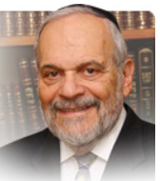

One of the primary commandments in Judaism is to marry and have children. In the Garden of Eden, we find Adam and Chava blessed by G-d and told to procreate and fill the world with people. For the Jewish people, having children has become a demographic necessity. Even though it is years since World II and the resultant Holocaust, the Jewish people has not as of yet made good on those immense losses in terms of population.

This is due to a lower-than-average birth rate amongst nonobservant Jews, a high rate of divorce, later-in-life marriages and an increasing population of singles. The ravages of assimilation and intermarriage also play a great part in the fact that Jews can hardly replace themselves, let alone make up for the deficit caused by the Holocaust.

**“Seeing Oneself ‘Past the Grave”**

The Torah places a high priority on children. It sees in children not only the physical continuity of the Jewish people but also a spiritual and heavenly connection that transcends one's life span. The rabbis commented regarding our father Jacob that as long as his descendants were alive and functioning then Jacob himself, so to speak, was also still alive.  Seeing oneself ‘past the grave,’ is one of the hallmarks of Judaism and of the Jewish people. The concept of the immortal soul is reinforced by being able to project forward in time, living vicariously in the lives of one’s descendants.

But, my friends, we all know that having and raising children is no easy task. And we also know that a parent remains a parent for one's entire life. I feel that this is one of the subtle messages conveyed at the beginning of this week's Torah reading. The Torah speaks of impurity, sacrifice, and isolation of the mother after the birth of a child. This is the Torah’s indication that these are factors that are unavoidable in the raising and nurturing of a child.

**A Book of Practical Human Life**

In all human society it is natural, indeed expected, for parents to do everything possible to give their children a good and healthy life. Those parents who do not somehow have that instinct within them are shunned in society and even liable to criminal punishment for neglect or abuse of their children. They are, even in our most open and liberal society, treated as being aberrant and cruel. The Torah, which is the book of practical human life, minces no words in describing the difficulties – impurity, sacrifice, and separation from others – that having and raising children automatically brings to parents.

It is perhaps for this very reason that the Torah gave women such a strong maternal instinct and the desire to have children. For without that instinct, based only on the practicalities of life and the difficulties of raising children, Jewish demographics would, in a practical sense, offer us no hope whatsoever for the future. The rabbis in Avot correctly stated that “the reward is directly commensurate with the effort and sacrifice.” That is certainly true as far as children and generations and the Jewish future is concerned.

*Reprinted from the current website of rabbiwein.com*

**Rav Avigdor Miller on**

**Celebrating Pesach in a Hotel**

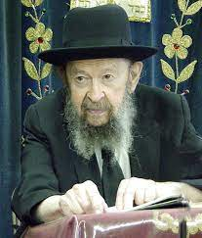

**QUESTION:** Do you approve of celebrating Pesach in a hotel?

**ANSWER:** And the answer is I do not. I definitely disapprove of hotels for Pesach.

Now, some hotels are definitely not kosher lePesach despite the fact that they say so; but I’m not talking about that. And some hotels are kosher lePesach but they provide other kinds of activities that are not in consummate with Pesach spirit; and I’m certainly not talking about that either. I’m talking about a hotel where there are no Broadway shows. There’s not even a television there. There’s nothing there except seforim in the beis hamedrash and everything is 100% kosher – even better than in your own home. And still, I say Pesach is a home celebration. The Seder is kodesh kodoshim in your own sanctuary, your own Beis Hamikdash.

It’s an opportunity given by Hakadosh Baruch Hu that is intended to raise the spirit of the home. Pesach is for a family, that’s what it is. And the father gets together with his children in the hallowed atmosphere of the Seder, and he hands over to his children the story of Yetzias Mitzrayim, the birth of our people. Not some official singer or a chazan or even an official rabbi.

The father! The father represents the whole background of Jewish tradition; and every child should be able to say, “My own father is handing this over to me like his father handed it over to him; and the chain goes back, link by link, to Har Sinai, link by link to Yetzias Mitzrayim.” That’s what Pesach should be. The home becomes a holy place. I definitely disapprove of going away for Pesach. There are no two ways about it.

*Reprinted from the Parshas Tazria 5784 email of Toras Avigdor. Transcribed from Tape #263 (April 1979).*

**The Purpose of Divine Punishment is for the Goal**

**of Refining the Sinner**

**From the Teachings of the Lubavitcher Rebbe**

**Rabbi Menachem Mendel Schneerson, Zt”l**

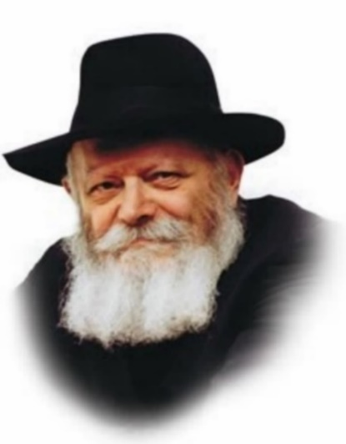

The name of a Torah portion is indicative of its contents and theme. The name of the first of this week's two readings, Tazria (literally "when [she] shall conceive") is therefore surprising at first glance, as the entire portion deals with the affliction of leprosy rather than conception and birth. In fact, the Biblical plague of leprosy was the most severe form of spiritual uncleanliness, leading our Sages to declare, "The leper is considered as if dead."

Tazria, however, is an allusion to the positive, inner purpose of all the afflictions and punishments that are prescribed in the Torah, as will be explained:

G-d is the epitome of goodness and loving-kindness. He doesn't punish anyone for the sake of being punitive. His sole intention is to refine and purify the person, to remove the "shell" that was created by his sins, and to elevate him to a higher level. All of the Torah's punishments, even the most stringent, are for the ultimate good of the recipient.

This is also the inner intention of the Biblical plague of leprosy (tzara'at), as distinguished from the modern-day illness known as Hansen's Disease. As Maimonides explains, the physical manifestations of tzara'at were miraculous in nature, and were visited on an individual for the sin of lashon hara (gossip).

"The first symptoms would appear on a person's house; if he repented, the house would be purified. If he persisted in his wickedness until the house was destroyed, the leather garments in his house would begin to change... If he persisted in his wickedness until they had to be burned, the clothing he wore would be afflicted." It was only if a person did not return to G-d after all these warnings that any symptoms of tzara'at would appear on his body.

Once this happened, the afflicted person had to temporarily leave the rest of society and dwell in isolation. The purpose of this period of separation and reflection was to transform the former sinner into a new entity, one that was purified and refined.

The name of the Torah portion, Tazria, thus reveals the true objective of all the Biblical plagues: the "birth" of a new being, a purer and holier Jew.

This is also the inner meaning of the Jewish people's exile. During the exile, we "sow" mitzvot and good deeds that they may "grow" and flourish when Moshiach comes. The reward we will receive in the Messianic era will not be dissociated from our present service; on the contrary, it will be the natural outgrowth of all the "seeds" we are planting now.

May we merit to see this immediately.

*Reprinted from the Parshat Vayikra 5761/2001 edition of L’Chaim Weekly. Adapted from volume 22 of Likutei Sichot.*

**Thoughts that Count**

*When a woman conceives and gives birth to a male, she shall be impure for seven days* (Lev. 12:2)

In principle, spiritual impurity is caused by the departure of holiness. A holy place or object becomes unclean when the sanctity that once rested on it is no longer there. (It is for this reason that a dead body is considered impure, i.e., the soul that animated it has departed.) Our Sages taught that only G-d holds the "key" to the miracle of birth; only He can "open" the womb or keep it closed. Every birth is therefore a manifestation of holiness, after which the sanctity departs, creating a state of spiritual impurity. *(The Kotzker Rebbe)*

*Upon the completion of the days of her purity for a son or for a daughter* (Lev. 12:6)

Up until the "completion of the days of her purity" the newborn is referred to as a "male" or "female"; only afterward does the Torah call the baby a "son" or "daughter." According to the Torah, 30 days must elapse before a neonate is considered out of danger. *(Meshech Chochma)*

*Reprinted from the Parshat Vayikra 5761/2001 edition of L’Chaim Weekly.*

**A Disgraceful Acceptance Speech at the Oscars**

**By**[**Rabbi Menachem Lehrfield**](https://aish.com/authors/130110013)



***Jonathan Glazer, the Jewish director of The Zone of Interest, equated Israel with Hamas and turned his back on his people.***

When accepting the Oscar for Best International feature at the Oscars for his trailblazing Holocaust film, The Zone of Interest, director Jonathan Glazer chose to turn his back on his people.

In his acceptance speech, he stated to roaring applause, “Our film shows where dehumanization leads at its worst. Right now, we stand here as men who refute their Jewishness and the Holocaust being hijacked by an occupation which has led to conflict for so many innocent people, whether the victims of October 7 in Israel or the ongoing attack in Gaza.”

Never mind how confusing his statement is. Is he refuting his Jewishness? Refuting how his Jewishness and the Holocaust is being hijacked? How? What occupation? Israel hasn’t occupied Gaza since 2005. What is clear is his lack of moral clarity. Glazer equates Hamas’s unprovoked massacre of Jews, murdering 1200, raping scores and taking hostage 240 innocent Israelis with Israel’s response to an existential threat to its people. If Hamas would release the hostages, put down its arms and renounce violence, peace would be at hand. It is a disgrace for someone to use the memory of the Holocaust to equate victim with perpetrator.

And Jonathan, if you did mean to refute your Jewishness, which I suspect you didn’t, the Jews who thought they could refute their Jewishness during the Holocaust ended up in the same gas chambers as those who proudly held on to their Jewish identity until their last breath.

I can understand a call for ceasefire and peace, but at this pivotal moment you said nothing about the 130 hostages who are still being held by Hamas in Gaza. Shame on you to use such a prominent platform to cave into the propaganda of Hamas, enemies who would like nothing more than to replicate the Holocaust. This is the time Jews around the world need to stand with their people and to proudly state that you are a Jew.



[**Rabbi Menachem Lehrfield**](https://aish.com/authors/130110013)

I am proud to be a Jew. I am proud to be part of the people that is fighting a just war, a people who wants nothing but peace.

I celebrate our heritage as a people who have bestowed upon the world the concepts of equality, sanctity of life and the dignity of the human being made in the image of G-d.

Your film shows the great evil human beings can do to each other, and the need to fight evil.

Today, don’t confuse those fighting for civilization and decency with those fighting for murder and savagery. It is not too late to retract your remarks.

*Reprinted from this week’s website of aish.com*

**A Time for Baking Hand Matzos for Pesach (Passover)**

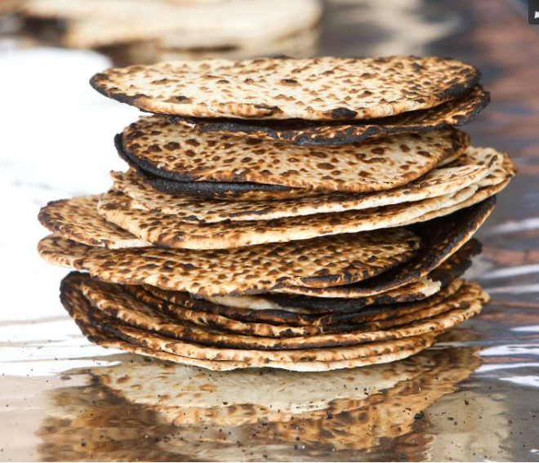

**Making matzot in Baka, Jerusalem**

**(photo by Marc Israel Sellem)**